CHAPTER 1: WHO YOU ARE AT 2 AM

HERO SECTION
Chapter Title: Who You Are at 2 AM
Hook: Hour 78. Hydraulic fluid everywhere. Thor slab won't budge. Backup equipment destroyed. Monday deadline looming. This is when you discover who you really are.
Featured Quote: "Faith and doubt are both beliefs. The difference is which story you choose."

What 78 Hours Teaches About Who You Really Are
The Real Discovery: The El Paso job wasn't about concrete or construction. It was about discovering that your character isn't what you claim—it's what emerges when everything goes wrong and no one's coming to save you.
Key Realizations from Hour 78:
- You Don't Know Your Character Until It's Tested
LinkedIn profiles and business cards tell you nothing about who someone really is. Character only reveals itself under pressure.
- 2 AM Decisions Define Everything
When you're exhausted, covered in hydraulic fluid, and facing failure, that's when your true self emerges. That person—not the daytime version—determines your destiny.
- Problems Reveal Capability
Every disaster is a capability test disguised as a crisis. El Paso taught me that problems don't just happen to you—they happen for you.
- Ownership Changes Everything
The moment you stop asking "Why is this happening to me?" and start asking "How do I solve this?" everything shifts.

Hey, welcome to the real story...
I’m glad you’re here. So you just read Chapter 1 in the book, right? The El Paso disaster. Hour 78. All that craziness.
Look, I know how this sounds. "78 hours straight." "Turned construction equipment into medieval siege weapons." "Hydraulic fluid everywhere."
It sounds like I'm exaggerating for effect, right?
The El Paso Footage You Have to See to Believe

Here's what I couldn't fit in those pages... I brought a GoPro and I had big plans for capturing the entire job in a time-lapse; however, at the first sound of the hammer bouncing on the concrete, that went out the window. I did have just enough time to put it on a cabinet and hit record. It lasted a few hours until the battery died but I’m really glad I was able to get that much.
In it you can see the paper rolls in the background and the formwork for the foundations that will be for the new machine. The were made out of plywood and temporarily held the concrete in place in the shape of drains.

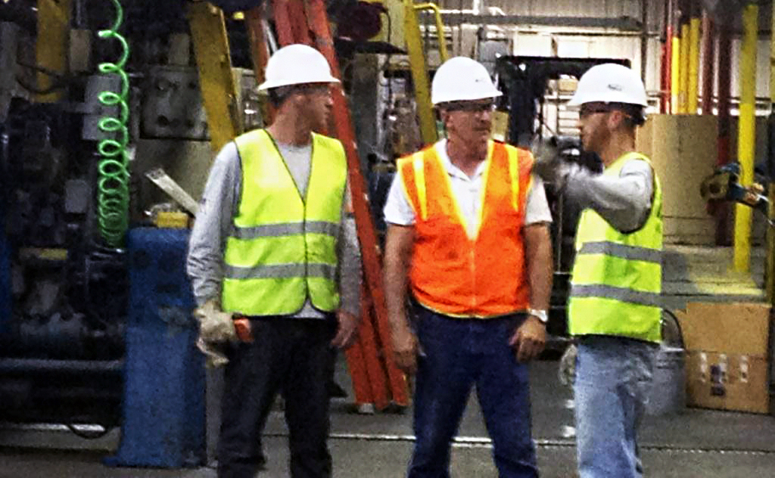
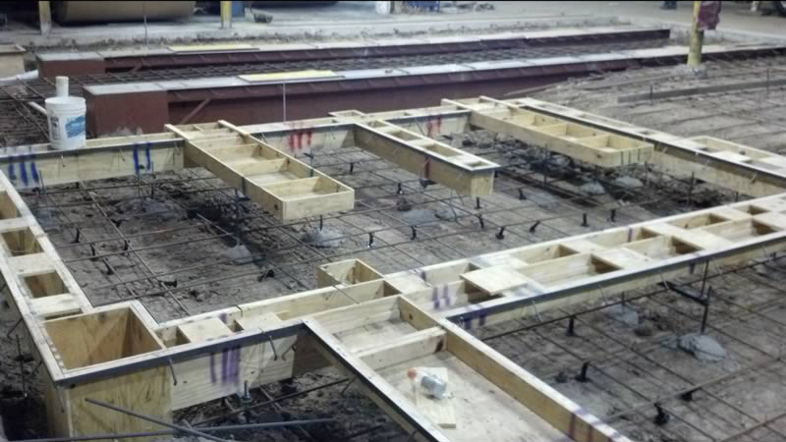
One of the things I didn’t go over in the book was that a couple of them came detached and floated up like a boat. We had to scramble and bust the bottom of them out so that we could jump up and down on them to push them back into the quickly hardening concrete! As you watch it you can see the pump over to the right as well as the concrete trucks we were bringing directly into the building. The plumbers show up and assess the situation. Since we were already started with our pour when the plant started up, we had no choice but to continue knowing that that had to fix it. There was no other option at this point.
My dad was still in full control of the company at that time still. We had not even become General Contractors yet. Me and Jake were both Superintendents and would run the crews.

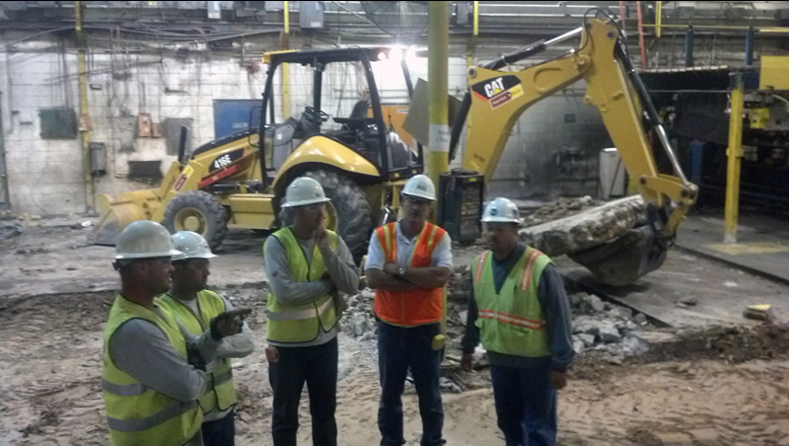
There were plenty of times where we tried to figure what we were going to do to solve this problem. We all knew we were in trouble but we also knew that there was no one coming to save us.
By 2 AM Sunday—19 hours in—Grandpa had gone to the hotel. The plant had grown quiet; everyone had gone home for the weekend. The backhoe with the hydraulic breaker was bleeding fluid like a wounded animal, limping out of the way. Now we were down to one backhoe and a 16-horsepower saw trying to cut through 20 inches of reinforced concrete.
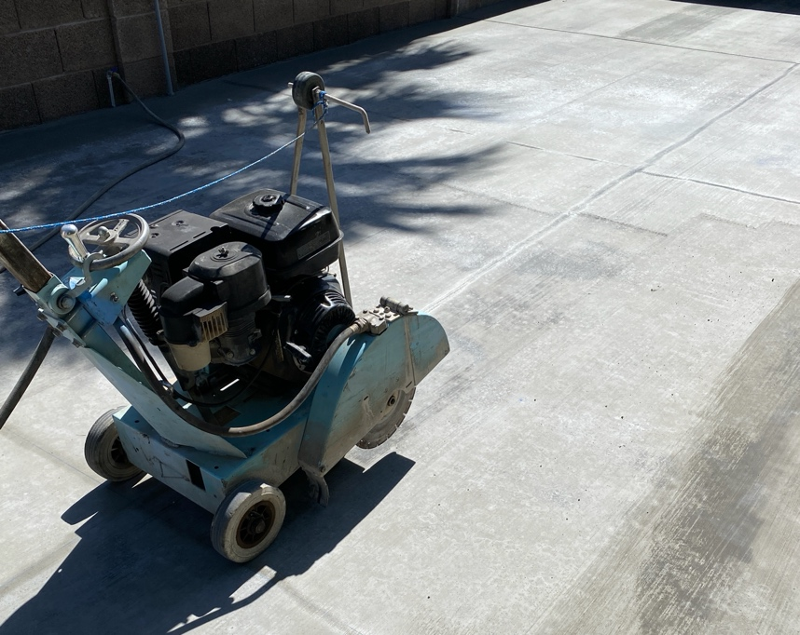
It was just me and your uncle Jake, staring at that Thor slab, knowing Monday was coming whether we were ready or not.

This is the tiny saw that saved the day. Our friend Robert, as he was leaving for the hotel, casually told Jake: “Why don’t you saw the concrete?” to which Jake replied, “what’s the point” and he said “what do you have to lose?” Haha indeed! So he did, he sawed for hours all through the night. It only could go down 6 inches, but that was just enough that it cut the top layer of rebar.
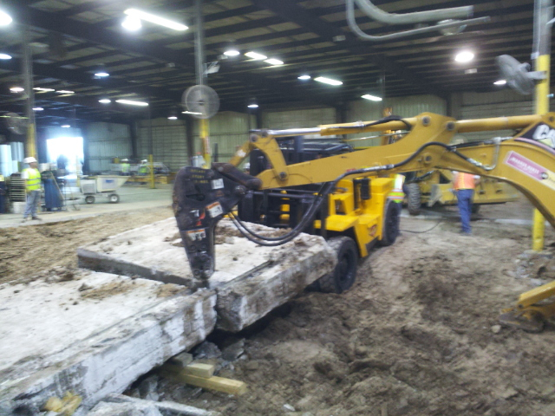
Ultimately, that was the reason the slab finally let go. In the morning we were able to get a hose company to fix the hose. The hammer still didn’t work but I could use it as a pry bar. In the background you can see the forklift also. It’s hard to tell in the picture but it is 20” thick and weighs over 50,000 lbs. The forklift could only lift half of it. We were at the max capacity of all of our equipment.

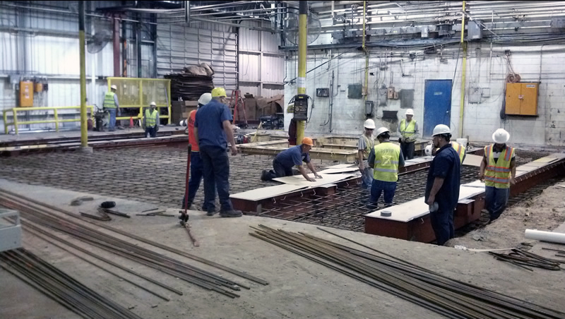

The metal pan inserts could only be lifted with the tractors. Fortunately we had two.

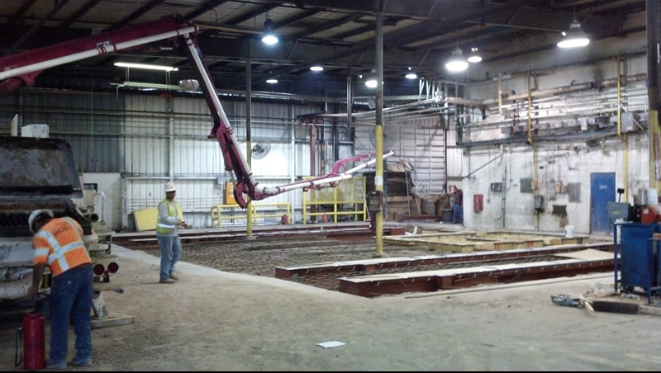
Honestly, I don’t remember taking any of these pictures. The whole job is a blur. This pump just barely fit. I mean, it was touching the ground when it unfolded and skimming the fire sprinkler pipe in the ceiling at the same time. When he hit the 8” water main in the ceiling my heart stopped, everyone stopped. I mean it when I say Noah’s flood. Those run at crazy pressures and put out ridiculous volumes of water. Before we had time to run to the fire riser room and shut it down, the foundation would have been a lake.
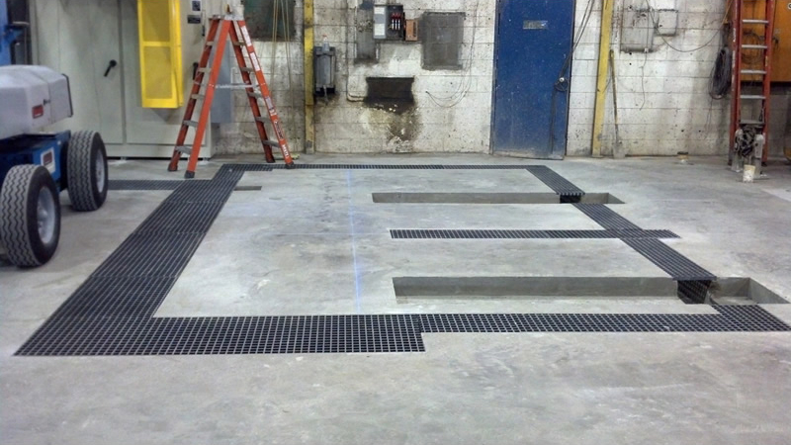
When it was all said and done, we did put out a great looking slab. There was a moment on Tuesday, when we were stripping the forms that one of the pipes between the drains didn’t work because it had filled with concrete. That pipe was necessary for wires and such and had to work but it was 18” below the top of the slab and wrapped in rebar. Fortunately we were able to break the concrete free, but it definitely had us worried for a bit.
That's when the lactose incident happened. But you'll have to read the book to find out how projectile vomiting on a drive home became a turning point in building character. Some stories are too good to spoil here.

WANT THE COMPLETE STORY?

Get The Fourth Generation Formula Book
This is just Chapter 1. The complete book contains 9 more chapters of stories, frameworks, and tools that reveal the exact formula for building generational wealth and breaking the family business curse.
What you'll discover in the full book:
- The lactose projectile incident and what it taught about leadership
- How a 10-year-old digging canals became an 8-figure empire builder
- The complete Builder's Formula: Identity + Action + Persistence
- 9 additional chapters of real stories and proven systems
- The exact blueprint that built Record Enterprises across 4 industries
Get Your Copy Direct From Kable →
"Every chapter has a QR code that brings you back here for exclusive content you can't get anywhere else."

The 2 AM Decision That Changes Everything
What I'm Really Trying to Tell You
Here's the thing about that moment at 2 AM...
It wasn't about concrete. It wasn't about construction. It wasn't even about finishing the job.
It was about discovering that the story you tell yourself in crisis becomes the story of your life.
From the book: "Faith and doubt are both beliefs. In that moment at 2 AM, covered in hydraulic fluid and concrete dust, while staring at a disaster that wasn't my fault but absolutely was my problem, I could have believed one of two stories:"
Story #1: "This is impossible. We're in over our heads. No one could fix this." Story #2: "We're going to finish this. We'll figure it out. We always do."
"At that moment, both were equally true. The difference was which story I chose to tell myself."
Most people choose Story #1. It's logical. It's reasonable. It's what any sane person would do.
But builders choose Story #2.
Not because we're crazy (though that helps). Not because we're stronger or smarter or better.
Because we understand something most people don't:
Your character isn't what you do when life is easy. It's who you become when everything goes wrong.

Your Own El Paso Moment
The Question That Reveals Everything
I get asked this all the time: "But Kable, I'm not in construction. How does this apply to me?"
Here's how:
Everyone has their own El Paso moment coming.
Maybe it's:
- The business deal that falls apart at the last minute
- The family crisis that tests every relationship
- The financial disaster that threatens everything you've built
- The health scare that puts everything in perspective
The specific situation doesn't matter. What matters is who you become when it happens.
From the book: "Will you be someone who finds reasons or someone who finds ways? Someone who explains why it couldn't be done or someone who figures out how to do it anyway?"
That choice—made at 2 AM when nobody's watching—determines everything that comes after.

Get the Complete El Paso Experience

Enter your email to access:
✅ The 2 AM Character Assessment (find out who you really are under pressure) ✅ "Your Thor Slab" worksheet (identify the impossible problem you're avoiding) ✅ Access to the private Chapter 1 discussion (share your own 2 AM story)
PLUS: FREE DOWNLOAD → "The 2 AM Decision Framework" A step-by-step guide for making character-defining choices when everything goes wrong

Digital Products & Tools In Development
Possible Future Offerings:
🚧 The Crisis Response Playbook - Complete system for turning disasters into opportunities (Planning Phase) 🚧 Builder's Identity Audio Course - 30-day program for developing unshakeable character (In Development)
🚧 El Paso Masterclass - Deep dive case study with decision-making frameworks (Concept Phase) 🚧 2 AM Character Assessment (Premium) - Advanced personality evaluation with custom action plan (Research Phase) 🚧 The Thor Slab Method - Problem-solving methodology for "impossible" challenges (Ideas Stage) 🚧 Daily Builder Affirmations App - Morning declarations and mindset training (Future Concept)
Want early access and input on what gets built first? Join the email list above and you'll be the first to know when these launch (plus get to vote on priorities).

What's Next?
Keep Going Deeper:
← Previous: Introduction - The Grocery Store Awakening
→ Next: Chapter 2 - Character Is Who You Are When No One Is Watching
Or Browse All Chapters: Complete Book Structure

P.S. - The Real Lesson
You know what I learned at 2 AM in that hole in El Paso?
It's not about the concrete. It's never about the concrete.
It's about becoming the kind of person who doesn't quit when quitting makes sense.
Because once you become that person—once you prove to yourself that you can figure out "impossible" problems—everything else becomes possible too.
That's what this whole book is about. That's what your legacy depends on.
Who you are at 2 AM when everything goes wrong.
See you in Chapter 2,
Kable

"Character isn't what happens to you. Character is what you do about what happens to you. El Paso taught me the difference." — Kable Record, The Fourth Generation Formula

